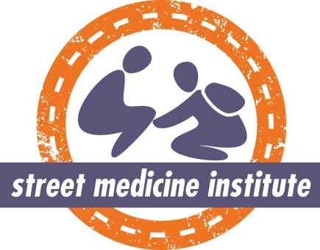
International Street Medicine Symposium XVI
October 14 – 17, 2020 Toronto, Canada

ISMS 16 Submission Details
All proposals to present at ISMS 16 must be submitted through the SurveyMonkey link: https://www.surveymonkey.com/r/ISMS16_Proposals. Please scroll through the pages below to view the questions you will be required to answer in order to submit your proposal. Depending on your answers to certain questions, you may not have to answer all questions on this survey and therefore the numbers to the questions you see on SurveyMonkey may not be the same as the numbers listed for each question here. All questions with asterisks (*) require an answer in order to move to the next set of questions.
Submissions must be received by midnight (EST) on Sunday, March 15, 2020.
Please note that ONLY the primary presenter is eligible for free registration for lectures, small-group oral presentations, small-group problem-solving sessions, and posters. Exceptions may be allowed for presentations in which a person with recent lived experience of homelessness is the primary presenter.

Please note that the primary presenter and the first co-presenter are eligible for free registration for workshops and expert panels only. All additional presenters will need to pay their registration fee in order to present. Registration fees vary by profession, with the highest fee for physicians and the lowest fee for students/trainees. People with recent lived experience of homelessness receive free registration.

Choices for Question 10 include:
A. Unsheltered or rough-sleeping people
B. People experiencing sheltered homelessness
C. People experiencing sheltered and unsheltered homelessness
D. People who have low income, but have never experienced homelessness
You will be prompted to answer Question 11 only if you select C or D as your answer to Question 10.
If you answer “No” to Question 22, you will be prompted to explain your answer in Question 23.
Questions?
Questions about the ISMS or presentation proposal submission process can be addressed to the organizing committee at lfrye@streetmedicine.org.
Submissions must be received by midnight (EST) on Sunday, March 15, 2020.

Submit your proposal to present at ISMS 16 now at: https://www.surveymonkey.com/r/ISMS16_Proposals

